**Selection Statements in C / Character Handling**

**Decision Making using If statement**

**if** statement performs an action if a condition is true. Conditions in if statements are formed by using the equality operators and relational operators

// using if statement

#include <stdio.h>

int main(void)

{

int no1, no2;

printf( “%s”, “Enter two integers : ” );

scanf( “%d%d”, &no1, &no2); // read two ntegers

**if ( no1 == no2 )** // checking equal

printf( “%d is equal to %d\n” , no1, no2 );

**if ( no1 != no2 )** // checking not equal

printf( “%d is not equal to %d\n” , no1, no2 );

return 0;

} // end of main function

Output

Enter two integers :3 3

3 is equal to 3

Enter two integers :5 3

5 is not equal to 3

**If statement cont…**

**if ( no1 == no2 )**

**{**

printf( “%d is equal to %d\n” , no1, no2 ); printf( “%s”, “Numbers are same ” );

**}**

* To include several statements in the body of an if, enclose the set of statements in braces ({ and })
* A left brace ( { ) begins the body of each if statement
* A corresponding right brace ( } ) ends each if statement body
* Any number of statements can be placed in the body of an if statement
* A set of statements contained within a pair of braces is called a **compound statement** or a **block**

**if …. else Statement**

* if ….. else statement performs an action if a condition is true and performs a different action if the condition is false

**/* printing pass or fail using if .. else #include <stdio.h>**

**int main(void)**

**{**

**int mark;**

**printf( “Enter marks : ” );**

**scanf( “%d”, &mark ); // read marks**

**if ( mark >= 60 ) // check whether mark greater than or equal to 60**

**{**

**printf( “%s”, “Passed” );**

}

**Else**

**{**

**printf( “%s”, “Failed ” );**

**printf( “You must take this again \n” );**

**}**

**return 0;**

**Conditional Operator**

* Conditional operator(?:) is related to the if ….else statement.
* It takes three operands. First operand is a condition. Second is the value if the condition is true. Third is the value if the condition is false.

Example

mark >= 60 **?** printf( “Passed\n” ) **:** printf( “Failed\n” );

Above statement is same as,

if ( mark >= 60 )

printf( “Passed” );

else

printf( “Failed” );

**Nested if…. Else statements**

* Nested if … else statements handle multiple cases by placing if …else statements inside if …else statements.

/* printing grade using nested if .. else #include <stdio.h>

int main(void)

{

int mark;

printf(“%s”, “Enter marks : ”); scanf(“%d”, &mark); // read marks

if ( mark >= 80 )

printf( “%s”, “Grade A” ); else if ( mark >= 50 )

printf( “%s”, “Grade B ” );

else if ( mark >= 40 )

printf( “%s”, “Grade C ” ); else

printf( “%s”, “Grade F ” );

return 0;

}

**Switch Statement**

* The switch statement is an alternative to the nested if-else statement provided the expressions can be written as:

(variable == value)

* The switch statement consists of a series of case labels
* Multiple statements can be executed for a given condition and break statement terminates the execution of the condition

**char data type**

* Characters are normally stored in variable type char
* Characters can be stored in any integer type variable too
* Characters can be treated as either an

*integer* or a *character*

* **getchar** function reads one character from the keyboard
* Characters can be read with **scanf**

by using the conversion specifier %c

**char data type cont…**

* Many computers today use ASCII(American Standard Code for Information Interchange) character set

Example:

printf( “The character (%c) has the value %d.\n”, ‘a’, ‘a’ ); Output :

The character (a) has the value 97.

* Conversion specifier %c and %d can be used to print character ‘a’ and its integer value
* 97 is the numerical representation of character ‘a’ in the computer.

**Iteration**

* Certain steps may need to be repeated while, or until, a certain

condition is true.

* We call it as a Loop

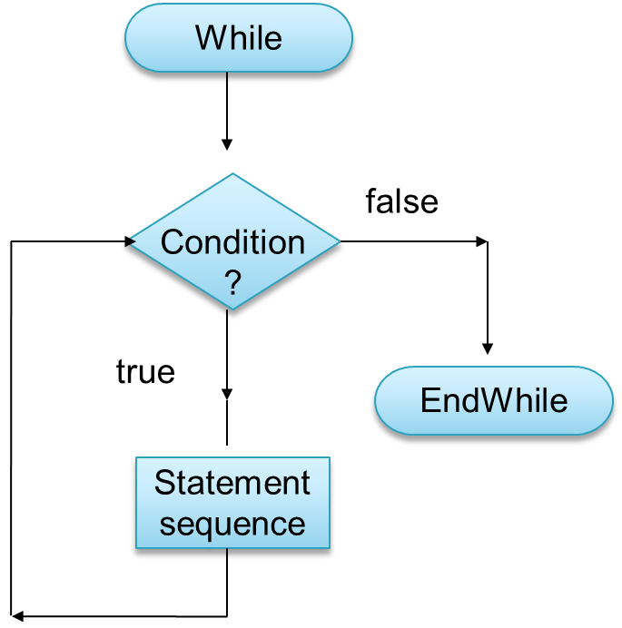

* Section(s) of an algorithm are repeated over and over (obviously these loops must eventually terminate)
* This is achieved by a test of whether a condition is true or false
* In a while loop we continue to repeat something **while a condition is true** – **we terminate the loop when it is false**